MINUTES OF THE REGULAR MONTHLY MEETING OF THE

JERSEY SHORE AREA JOINT WATER AUTHORITY
JERSEY SHORE, PENNSYLVANIA 17740
Chairman Richard W. Buttorff called the meeting to order at 6:32 P.M.
Members present were Barbara E. Schmouder, Richard W. Buttorff, Kenneth B. Bierly, Lisa L. Urbine, Brett S. Bowes, Krista J. Kephart, Katelyn A. Wasson and Samantha L. Mcllwain. Also, present was Manager Eric S. Johnston. There were two visitors: Jodi Heck from the Jersey Shore State Bank and Jason Fitzgerald from Penn Strategies.
- Jodi Heck from Jersey Shore State Bank presented a Proposal for lending up to 3.4 million dollars and the terms of the loan as well as fee and closing costs.
- Jason Fitzgerald from Penn Strategies presented the different grants for funding.
The minutes of the January 17, 2022, meeting was presented. Upon a motion by Krista J. Kephart, seconded by Kenneth B. Bierly to approve the minutes of the January 17, 2022, meeting as presented. The motion passed unanimously.
Eric S. Johnston presented the Manager's Report for February 21, 2022. A copy of the Manager's Report is in the minute book. A motion was made by Samantha L. Mcllwain, seconded by Lisa L. Urbine to accept the Manager's Report. The motion passed unanimously.
New Business:
- Resolution 2022-02-21 regarding Local Share Account Grant for the Pine Creek Water Treatment Plant Project. A motion was made by Samantha L. Mcllwain, seconded by Brett S. Bowes to approve Resolution 2022-02-21 regarding Local Share Account Grant for the Pine Creek Water Treatment Plant Project. The motion passed unanimously.
- Penn Strategies —A motion was made by Kenneth B. Bierly, seconded by Lisa L. Urbine, to Penn Strategies to submit for a Local Share Account Grant Application on behalf of Jersey Shore Area Joint Water Authority for the Pine Creek Water Plant Project. The motion passed unanimously.
- Appraisal for Pine Creek Water Treatment Plant Grant — A motion was made by Krista J. Kephart, seconded by Katelyn A. Wasson, to approve an Appraisal for Pine Creek Water Treatment Plant for Grant Funding Purposes. The motion passed unanimously.
Resolution 2022-02-21 — A motion to adopt Resolution 2022-02-21-A for Jersey Shore State Bank for Interim Financing for the Pine Creek Water Plant, Canoe Run and New Tribes 287 exposed waterline projects. The motion was made by Brett S. Bowes, seconded by Kenneth B. Bierly to adopt Resolution 2022-02-21-A for Jersey Shore State Bank for Interim Financing for the Pine Creek Water Plant, Canoe Run and new Tribes 287 exposed waterline projects. The motion passed unanimously.
- Discussion — Rate Structure, Future Rate Increases, Including Service Fees, Tap Fees, Unit Fees and Monthly Billing vs Quarterly Billing. It was decided to put in the hands of the Advisory Committee. A meeting is scheduled for March 11, 2022, at 11:00 a.m. at the Authority.
- Resolution 2022-02-21-B — Adoption of Resolution 2022-02-21-B USDA Rural Development Loan and Grant application for Pine Creek Water Plant. A motion was made by Lisa L. Urbine, seconded by Krista J. Kephart to approve adoption of Resolution 202202-21-B USDA Rural Development Loan and Grant application for Pine Creek Water Plant. The motion passed unanimously.
- Penn Strategies —A motion was made by Samantha L. Mcllwain, seconded by Kenneth B. Bierly, to have Penn Strategies submit an application to USDA Rural Development on behalf of Jersey Shore Area Joint Water Authority for the Pine Creek Water Plan Project. The motion passed unanimously.
- Vacant Lot for Sale — The lot at 1125 Bardo Avenue is for sale and the asking price if $49,900. It was the consensus of the board that it needed more research and information. Lisa L. Urbine is checking for further information regarding the property.
Copies of the above New Business items are in the minute book.
A motion to approve payment of the monthly bills in the amount of $51,452.71 was made by Krista J. Kephart, seconded by Brett S. Bowes. The motion passed unanimously.
A motion was made by Barbara E. Schmouder, seconded by Brett S. Bowes, to adjourn the meeting at 8:16 p.m. The motion passed unanimously.
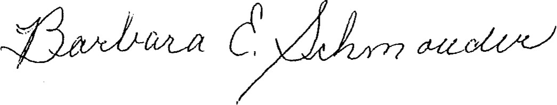
Barbara E. Schmouder, Secretary

