MINUTES OF THE REGULAR MONTHLY MEETING OF THE
JERSEY SHORE AREA JOINT WATER AUTHORITY
JERSEY SHORE, PENNSYLVANIA 17740
Chairman Richard W. Buttorff called the meeting to order at 6:30 P.M.
Members present were Barbara E. Schmouder, Richard W. Buttorff, Lisa L. Urbine, Krista J. Gephart, and Katelyn A. Wasson. Also, present was Manager Eric S. Johnston.
The minutes of the July 18, 2022, meeting was presented. Upon a motion by Krista J. Gephart, seconded by Lisa L. Urbine to approve the minutes of the July 18, 2022. The motion passed unanimously.
Eric S. Johnston presented the Manager's Report for August 15, 2022. There was discussion regarding the Oak Street paving restoration. A copy of the Manager's Report is in the minute book along with other pertinent data. A motion was made by Krista J. Gephart, seconded by Lisa L. Urbine to accept the Manager's Report. The motion passed unanimously.
New Business:
- A Motion to approve the form of the Mandatory Tap Ordinance as presented for all towns, boroughs, and municipalities that the Authority currently serves and areas that the Authority may serve in the future. The motion was made by Katelyn A. Wasson seconded by Barbara E. Schmouder. The motion passed unanimously.
- A Motion to have the Authority Solicitor, Mr. Paul Ryan, send the Mandatory Tap Ordinance to all Towns, Boroughs, and Municipalities that the Authority currently serve. The motion was made by Katelyn A. Wasson, seconded by Krista J. Gephart. The motion passed unanimously.
Harger Utilities — A motion to approve Harger Utilities Pay Request Number Two in the amount of $99,616.50 for Larrys Creek Water Line was made by Krista J. Gephart seconded by Lisa L. Urbine. The motion pass unanimously.
Caterpillar— Backhoe Loader was discussed, and it was decided to table to our September 19, 2022, meeting.
A motion to approve payment of the monthly bills in the amount of $174,993.59 was made by Krista J. Gephart, seconded by Katelyn A. Wasson. The motion passed unanimously.
A motion was made by Krista J. Gephart, seconded by Lisa L. Urbine, to adjourn the meeting at 7:40 p.m. The motion passed unanimously.
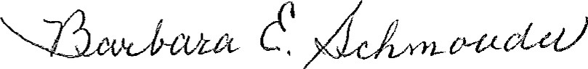
Barbara E. Schmouder, Secretary

